Annual Report 2021
German Welfare Council
Registered Charity Number: 288538

Patron:

His Excellence the Ambassador of the Federal Republic of Germany Andreas Michaelis

Committee:
Mr U. Bauer – Chairman
Mr U. Maynard – Vice Chairman
(resigned in January 2022)
Mr J. Rhys
Ms V. Gronewold
Ms B. von Alten
Mr A. Blum
Mrs A. Haase

Employees:
Mrs D. Scording (full-time qualified Social Worker)

Independent examiner:

TC Group
Level 1
Devonshire House
One Mayfair Place
London W1J 8AJ

Bank:
HSBC sort code: 40 04 07
Account number: 31055909

Our work in 2021 continued to be impacted by the Covid-19 pandemic and its changing rules and regulations to keep people safe. Consequently, we have had a reduced number of client consultations. Our priority was to only meet people in person that we could not have helped otherwise. The majority of advice was given over the phone, via email, or via skype or other video services. However, we have had more than 1100 cases which does not include anonymous callers.
Complying with the 2021 government guidance and restrictions we have been able to offer only 21 home visits, some of whom still needed support to apply for Settled Status and were people in remote areas with no access to other forms of help.
We offer
- Pension Advice - help and advice with German and UK pension
applications, Life Certificates
- advice for moving between Germany and UK, health insurance and
security systems after Brexit and benefits with Pre/Settled Status
- General Social Advice – benefits and health insurance in Germany
and the UK
- Support for vulnerable people

We continued to support clients during their Settled Status application pro-cess. After the official deadline in June 2021, applications were more complex as it would often require help to apply for a new German passport, giving a plausible reason for late applications or applying via post with a lengthy document.
We have helped clients in difficult personal circum-stances such as financial hardship, when commu-nicating with German organisations, but also worries around loneliness and the future.

Our gratitude goes to:
• • •

The German Ambassador Andreas Michaelis and his staff

Charities administered by the Kaiser Wilhelm II Fund

The German YMCA

Our corporate members and members

The old and young volunteers

The German parishes in England

All organisations and individuals, not specially mentioned

Talks and Training
In January our staff gave a talk in collaboration with the German Raphaelswerk to German Advisers about the UK and its social security systems.
In May Doreen held an information evening organized by the London SPD. More than 120 people joined in listening to topics such as German and British pensions, health insurance issues and helpful tips when moving between the two countries.
Doreen also used the opportunity for online training for Universal Credit, Benefits for EU Citizens, and laws around homelessness. In addition, she attended courses organized by German bodies such as health insurance abroad, child benefit, or the UK immigration system after Brexit.

Pension advice
We support clients in dealing with the German Pension Centre when applying for their old age pension, bereavement payments or incapacity payments. Some application forms are still available in German only, or the translated version is very difficult to understand, especially for people who have just lost a loved one and are usually not familiar with the German language. We help and support filling in all forms of applications in person or over the phone. We also advise which supporting documents are required for the application process and offer verification of those. Usually, the application process takes several months after which clients will receive a pension notification which are very long documents. We help our clients to understand them and answer any questions in regard to payment patterns and/or how the reward has been calculated.
Tax on German Pensions
Under the British- German Double Taxation Agreement German pensions which had been paid for the first time after 2010 are taxed in Germany. Even small pensions fall under the German Tax system, as someone who lives outside of Germany does not automatically qualify for a German Tax-free allowance. We make our clients aware of these circumstances and provide help filling in the EWR form and providing advice and details on how to contact HM Revenue and Customs. The German Tax authority does not contact our clients immediately to demand tax due and we have been able to help clients to arrange monthly payments.
If you have any questions in this matter, please do not hesitate to contact us.

Our Staff
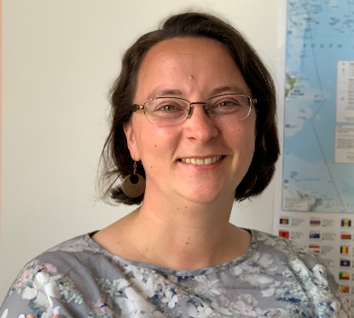
Doreen was born in Meerane, Saxony and came to the UK in 2006 after finishing her Degree in Social Work in Coburg. She also has a Master of Science in Ethnicity, Migration and Policy. Doreen has been working for the German Welfare Council since 2008 where she has refined her knowledge surrounding the British benefit system.

